1. The momentum of a particle is given by p(t) = 4.8t² i – 8.0 j – 8.9t k. What is the force as a function of time?

2. A golf ball of mass 0.045 kg is hit off the tee at a speed of 45 m/s. The golf club was in contact with the ball for 3.5 milliseconds. Find (a) the impulse imparted to the golf ball, and (b) the average force exerted on the ball by the golf club.

3. A car of mass 1000 kg travels east at 30 m s⁻¹, and collides with a 3000 kg truck
travelling west at 20 m s⁻¹. (a) If the collision is perfectly inelastic, how fast is the car
and truck going, and in which direction after the collision? (b) What happens if the
collision is elastic?

4. Two balls of are approaching each other as shown and are about to collide. Their masses are m₁ = 6.0 kg and m₂ = 3.0 kg. After colliding, they stick together. Find the resulting velocity of the two balls after collision.
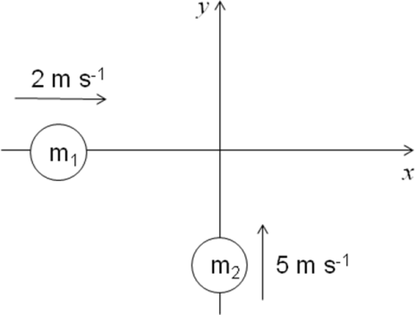

5. Two asteroids of equal mass in the asteroid belt between Mars and Jupiter collide with a glancing blow. Asteroid A, which was initially travelling at 40.0 m/s, is deflected 30.0° from its original direction, while asteroid B, which was initially at rest, travels at 45.0° to the original direction of A. (a) Find the speed of each asteroid after the collision. (b) What fraction of the original kinetic energy of asteroid A dissipates during this collision?
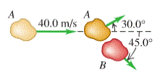

6. Two identical masses are released from rest in a smooth hemispherical bowl of radius R from the positions shown. You can ignore friction between the masses and the surface of the bowl. If they stick together when they collide, how high above the bottom of the bowl will the masses go after colliding?
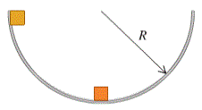

Answers

1. 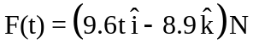
2. a) 2.0 kg.m/s in forward direction b) 580 N in forward direction
3. a) 7.5 m s⁻¹ west b) car: 45 m s⁻¹ west, truck: 5 m s⁻¹ east
4. 1.33 m/s, 1.67 m/s
5. a) V_{A after collision} = 29.3 m/s, V_{B after collision} 20.7 m/s b) 19.6 %
6. R/4

